SQL JOINS EXERCISE
Student No: 2805001764
Name: Jafter Selelo

Part A — INNER JOIN

Question 1:
PART A — INNER JOIN
Show Tables
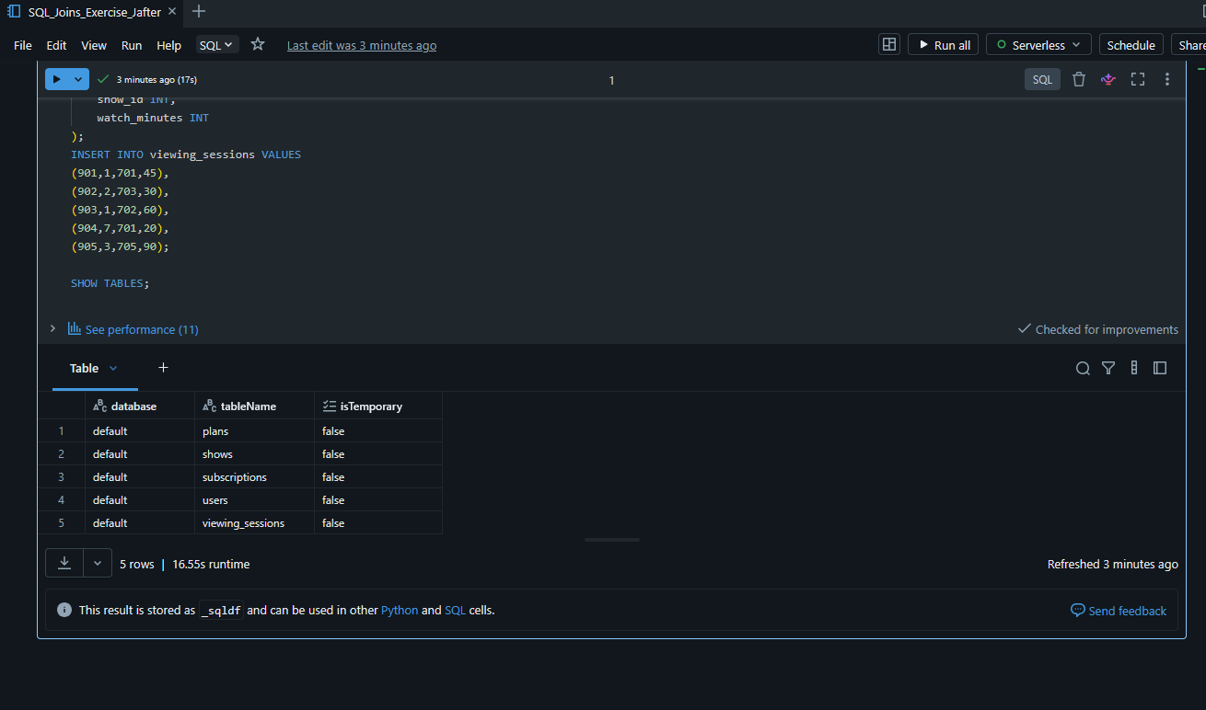
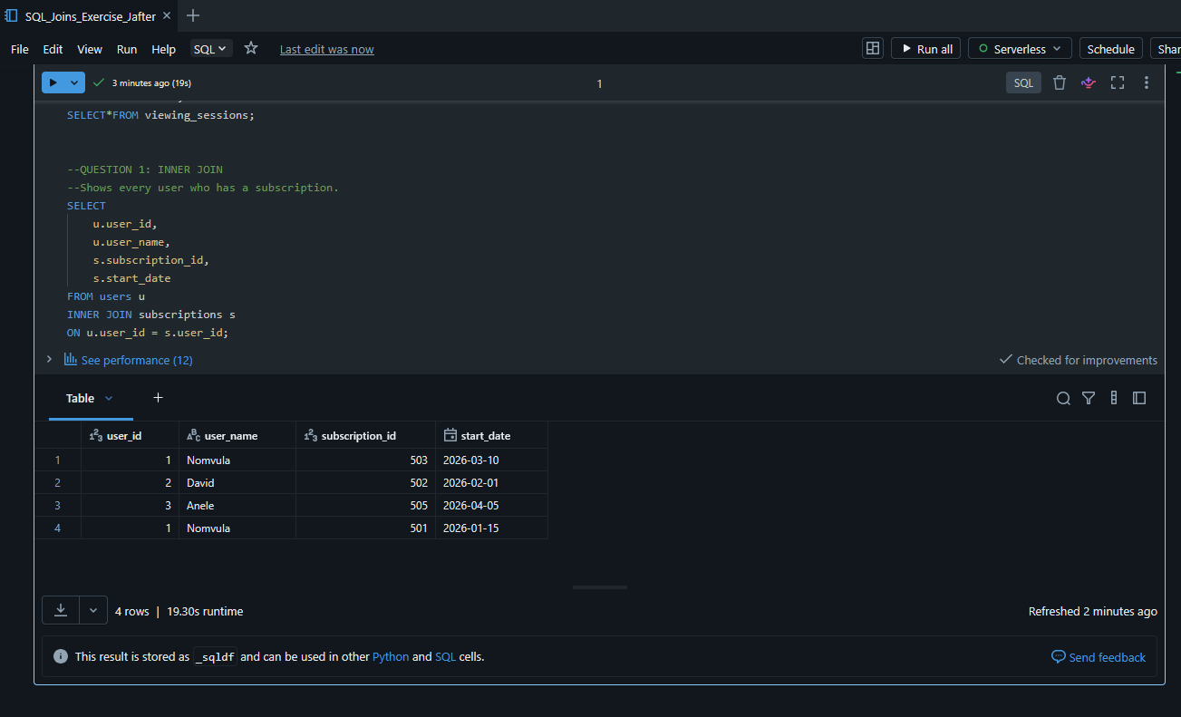

QUESTION 2:

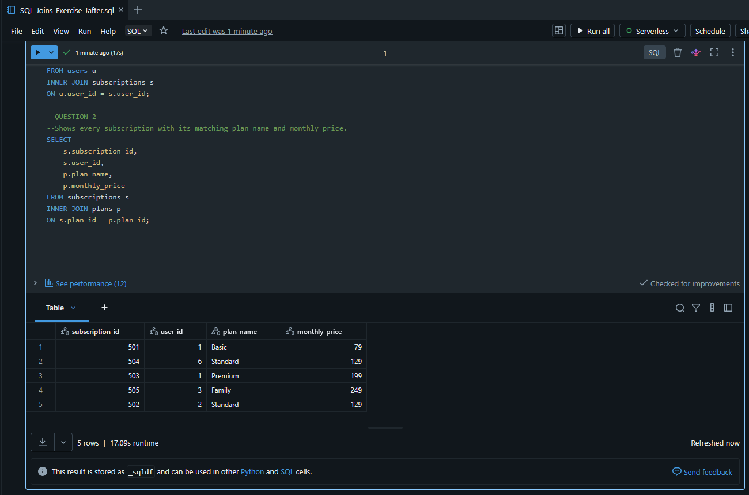

QUESTION 3:
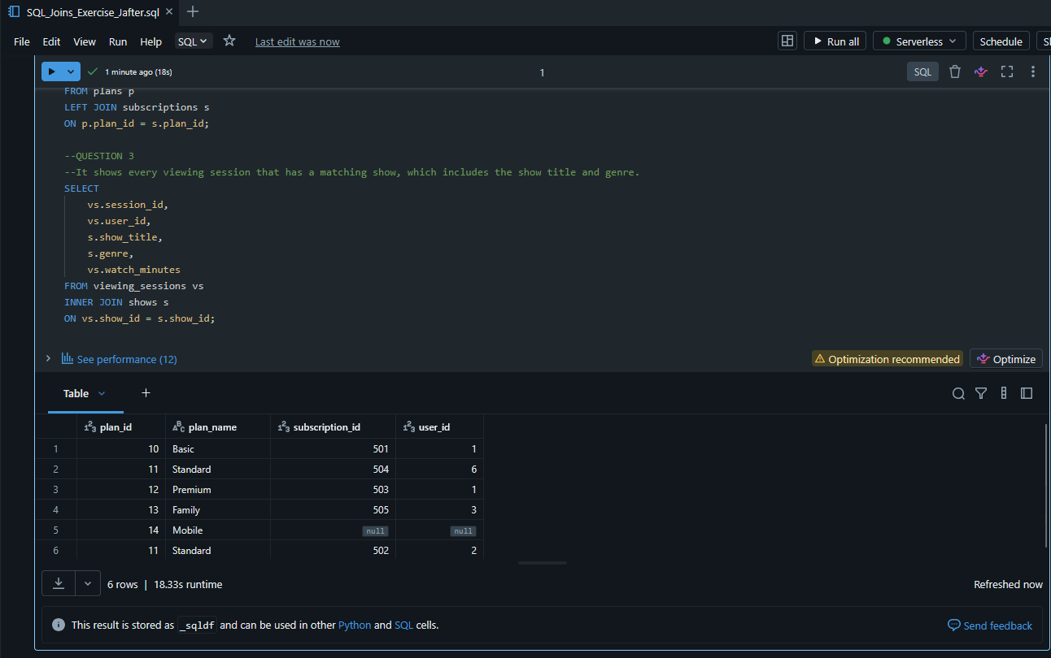

QUESTION 4:
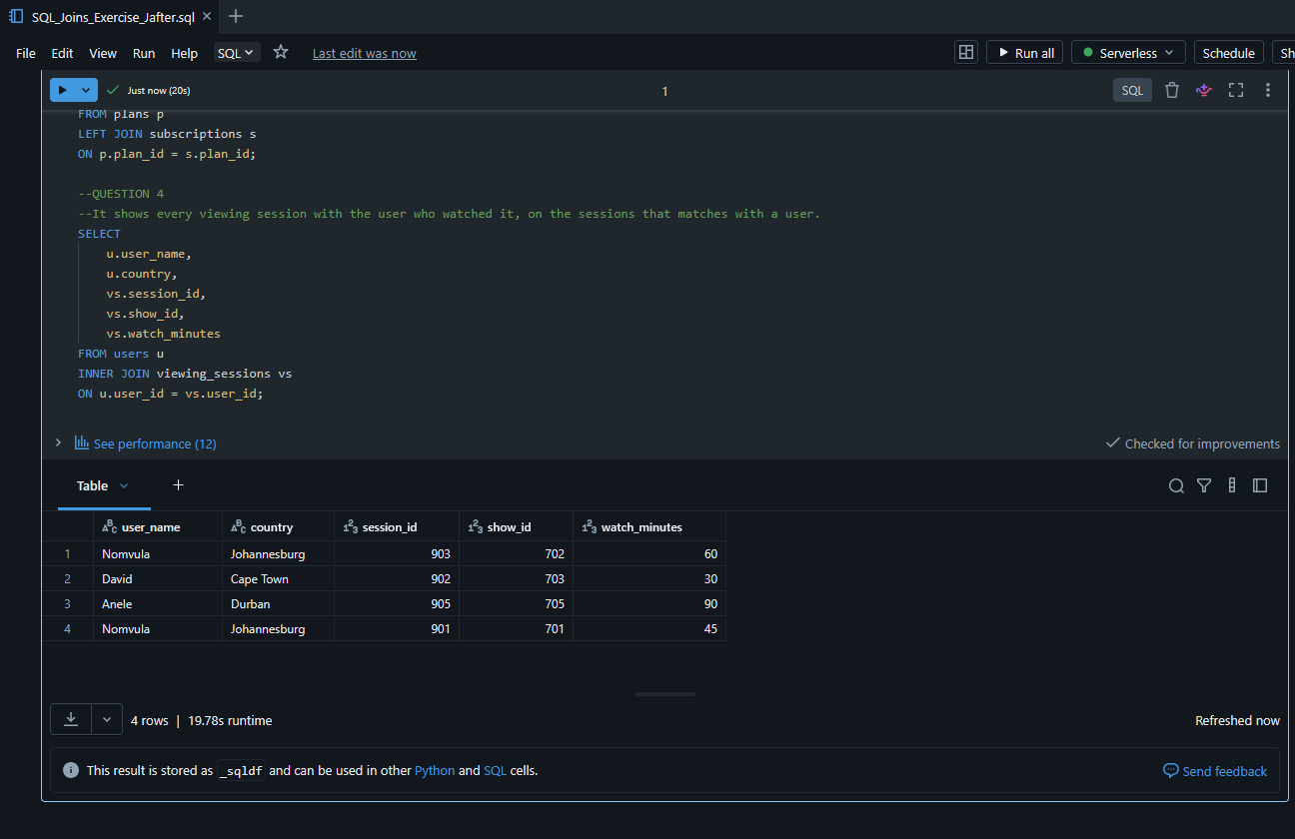

QUESTION 5:
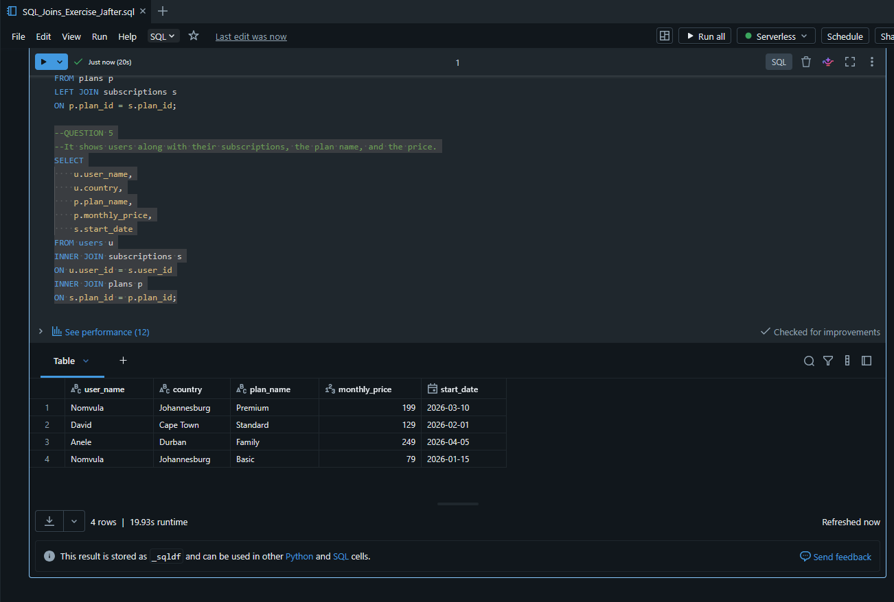

QUESTION 6:
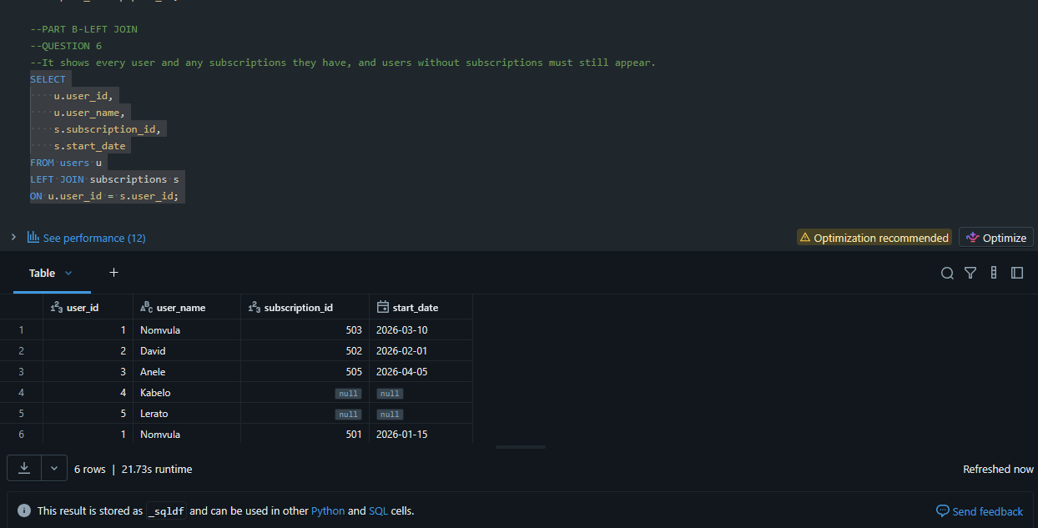

QUESTION 7:
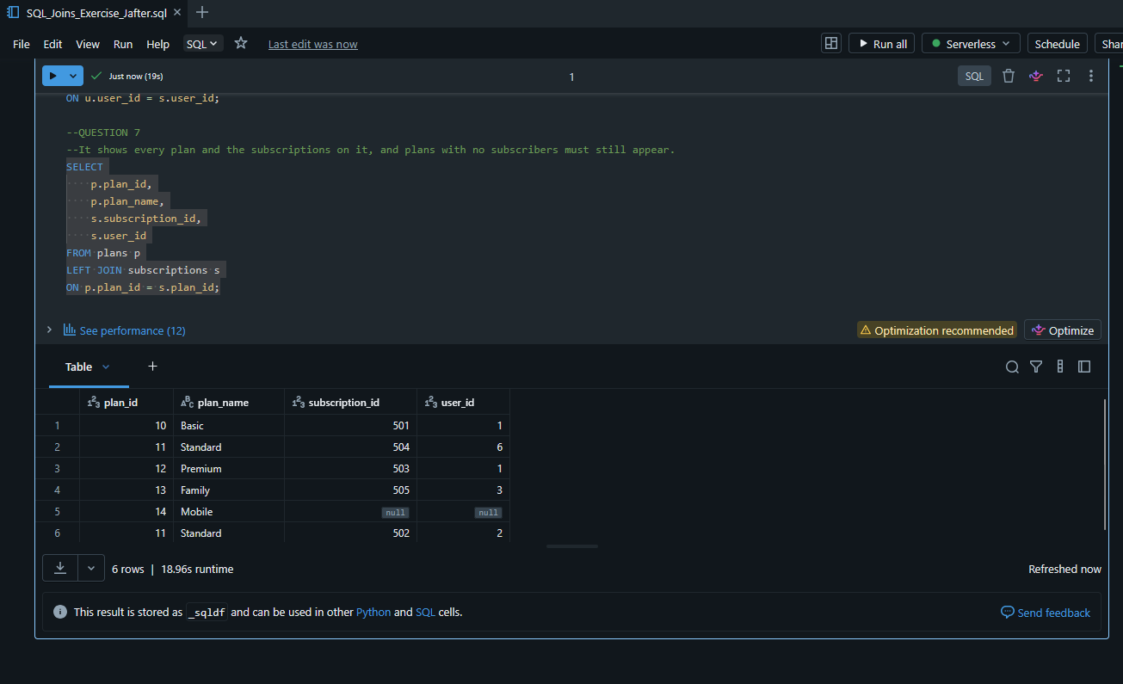

QUESTION 8:
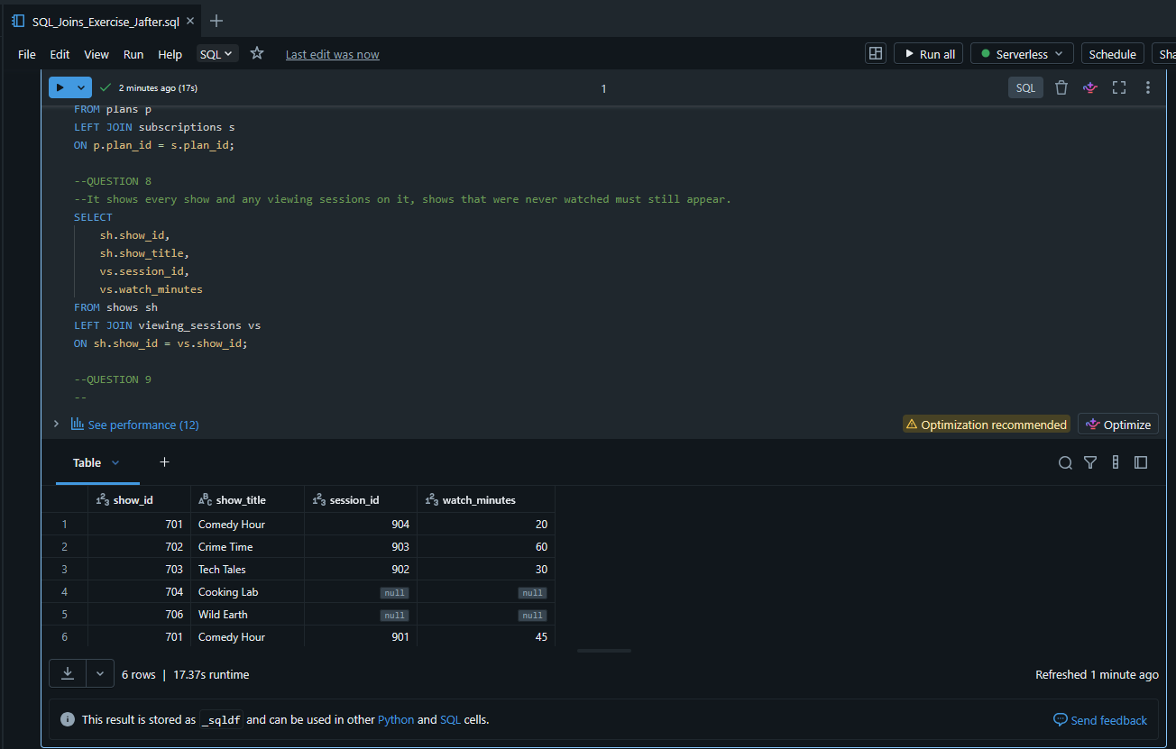

QUESTION 9:
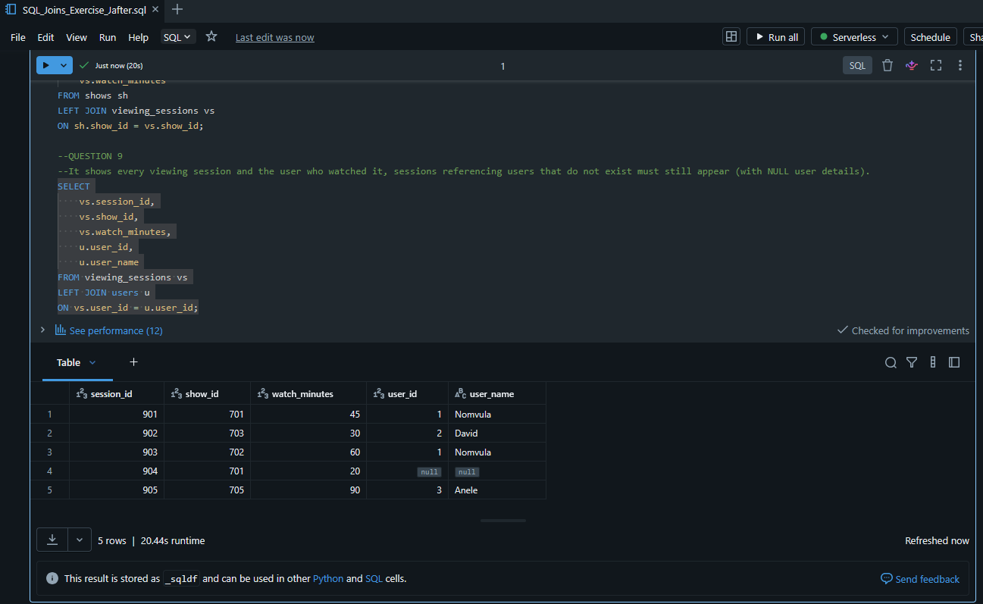

QUESTION 10:
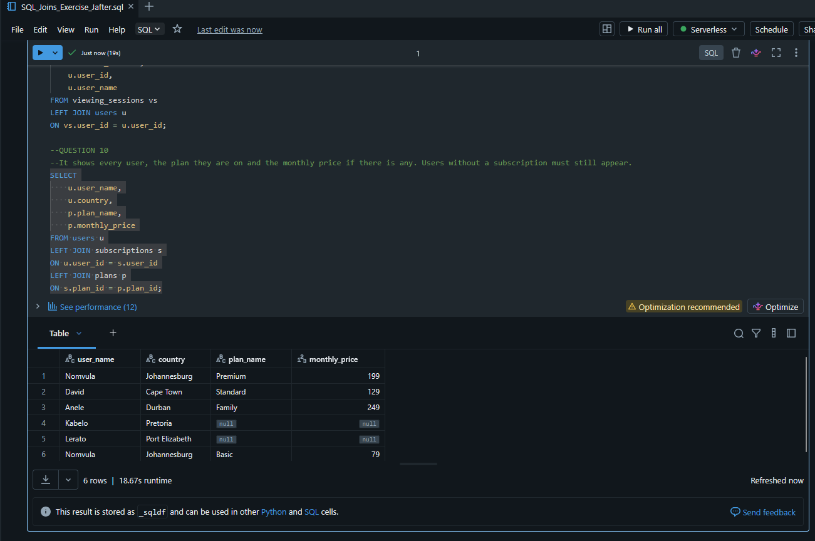

QUESTION 11:
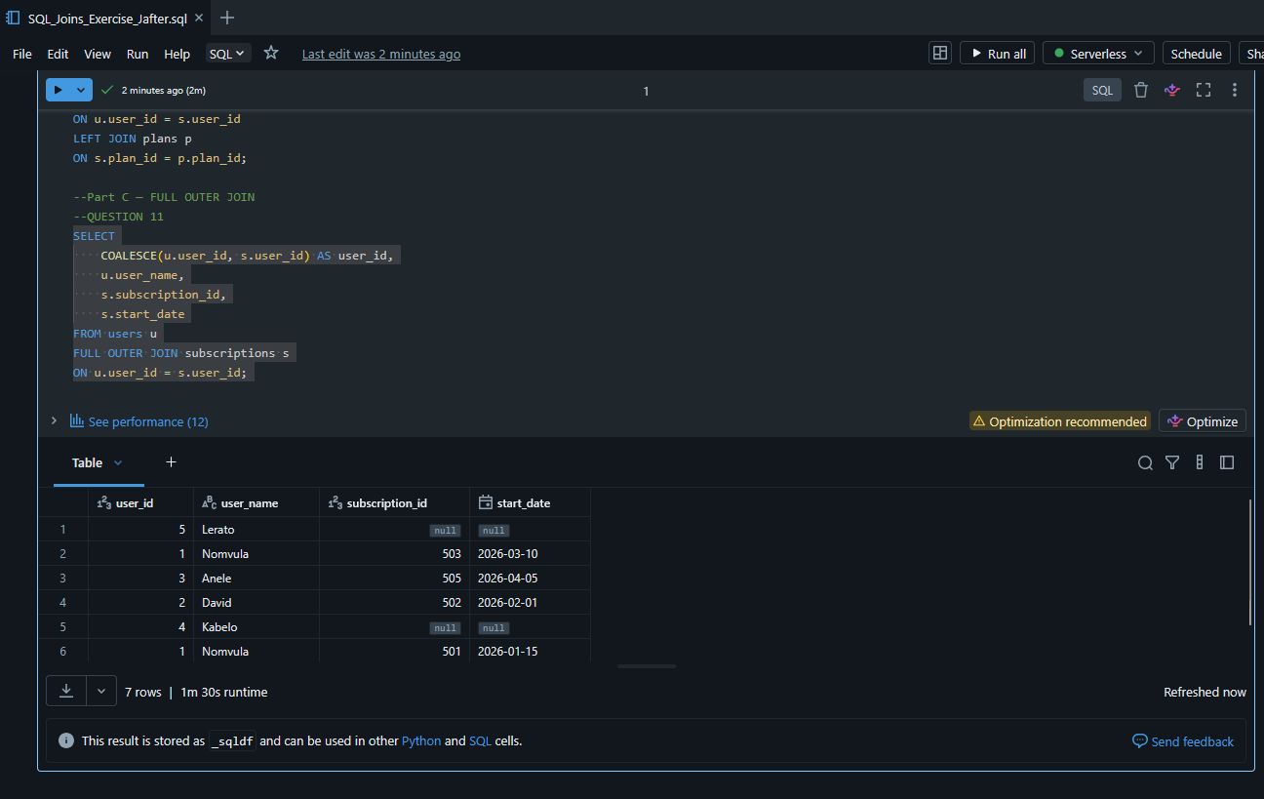

QUESTION 12:
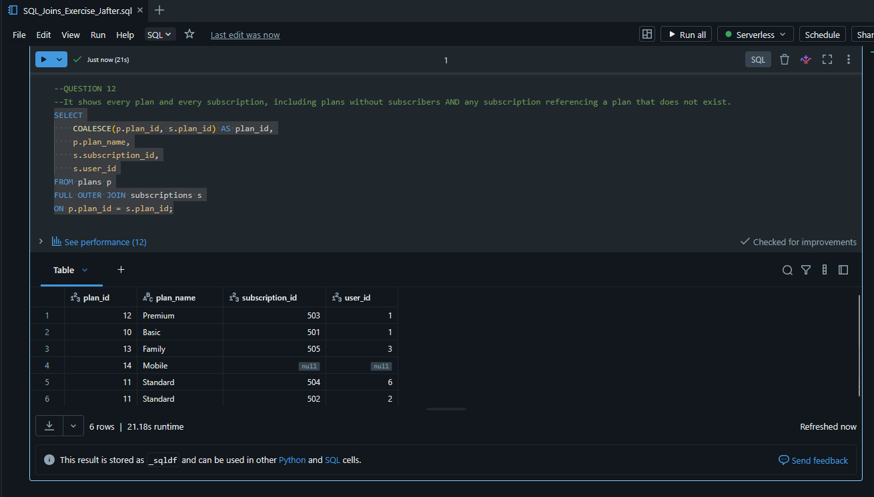

QUESTION 13:
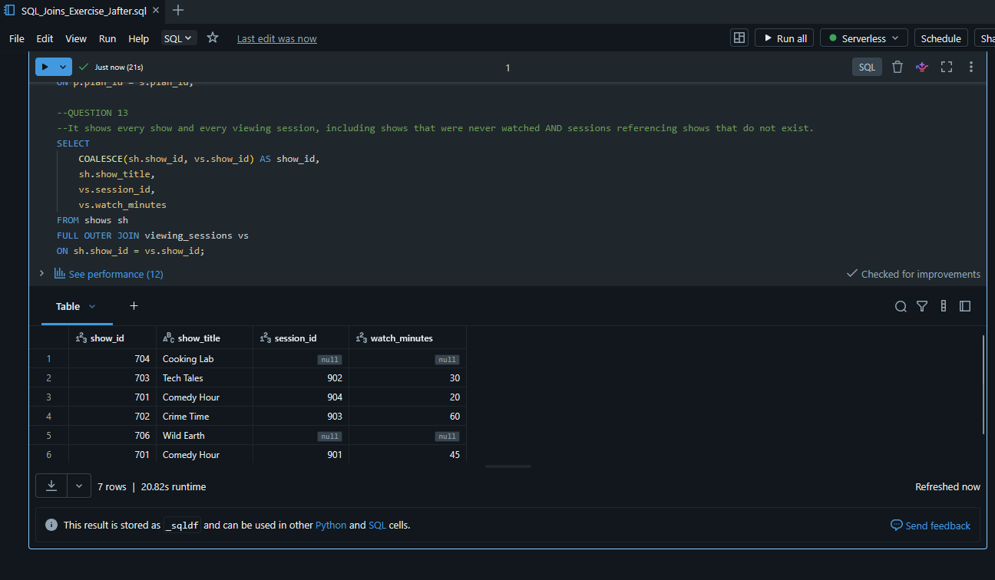

QUESTION 14:


QUESTION 15:
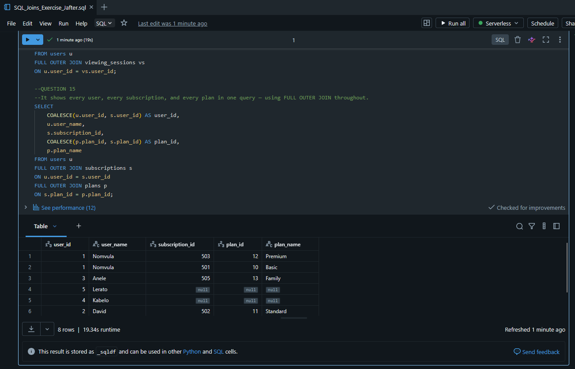

BONUS CHALLENGE ANSWERS:

- Bonus 1
Users with no subscriptions are:
- User 4- Kabelob.
- User 5-Lerato

2. Bonus 2
Subscriptions referencing users that do not exist:
- Subscription 504
- User ID 6 does not exist in users table

3. Bonus 3
Shows never watched:
- Show 704 - Cooking Lab
- Show 706 - Wild Earth

4. Bonus 4
Viewing sessions reference shows that do not exist are:
- Session 905
- Show ID 705 does not exist

5. Bonus 5
Plans with no subscribers are:

- Plan - Mobile

